Student Name : Pyae Phyo Aung
Student ID : 0526017003

Task 1:
Create and manage an Ubuntu container by completing the following steps:
1. Pull the latest Ubuntu image from Docker Hub.
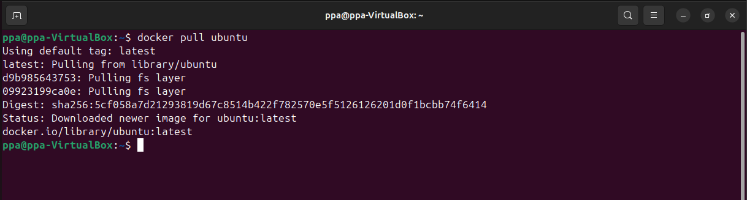

2. Create and run a container named student-ubuntu.

3. Display the list of running containers.
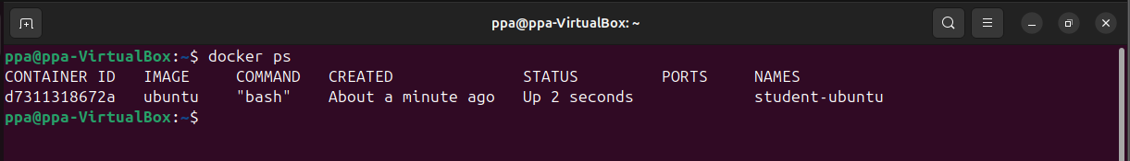

4. Stop the container.
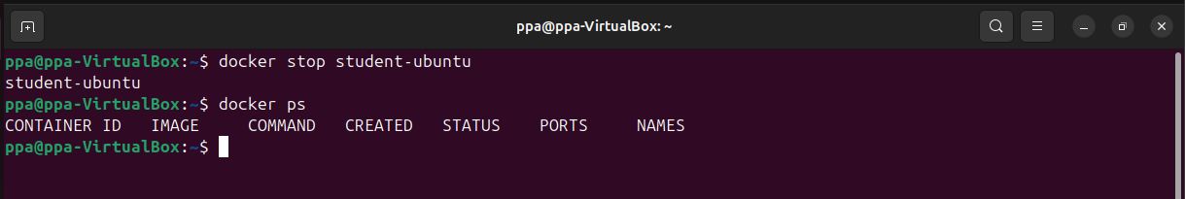

5. Display all containers, including stopped containers.
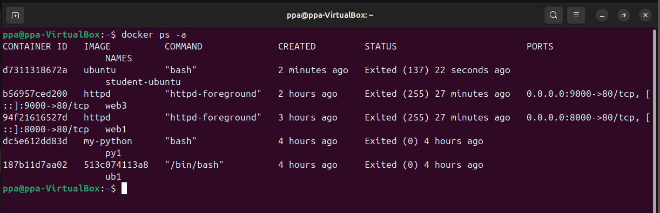

6. Restart the stopped container.
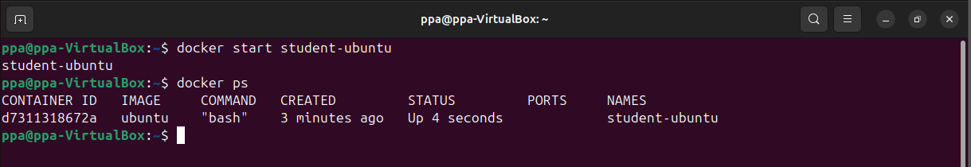

7. Access the container’s terminal and create a text file named student_info.txt.
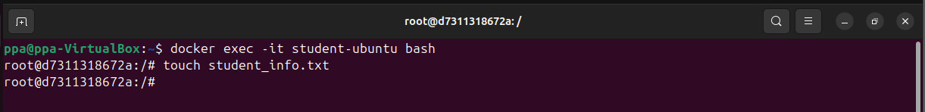

8. Add your name and student ID to the text file.
9. Display the contents of the file.
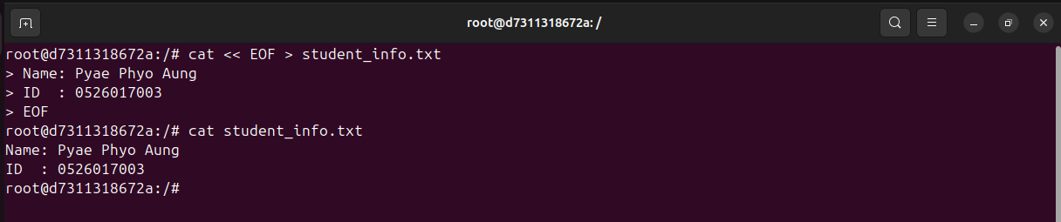

10. Stop and remove the container.
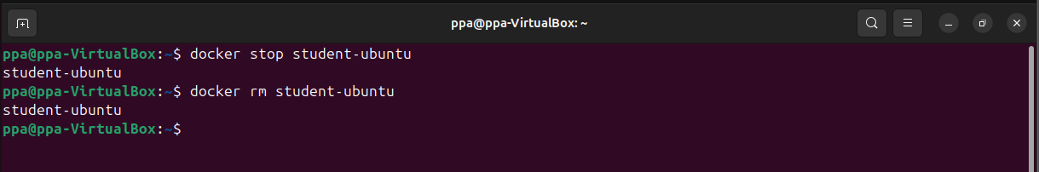

Task 2:
Create a custom Docker image containing Python by completing the following steps:
1. Create and run a new Ubuntu container named python-container.
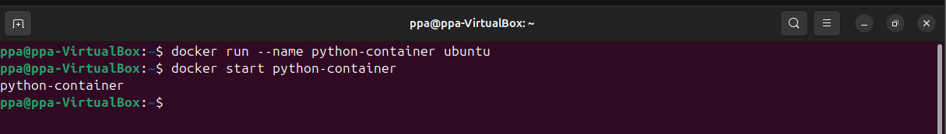
2. Access the container’s terminal.
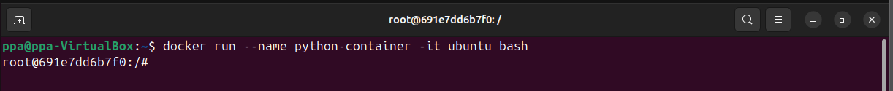
3. Update the Ubuntu package list.
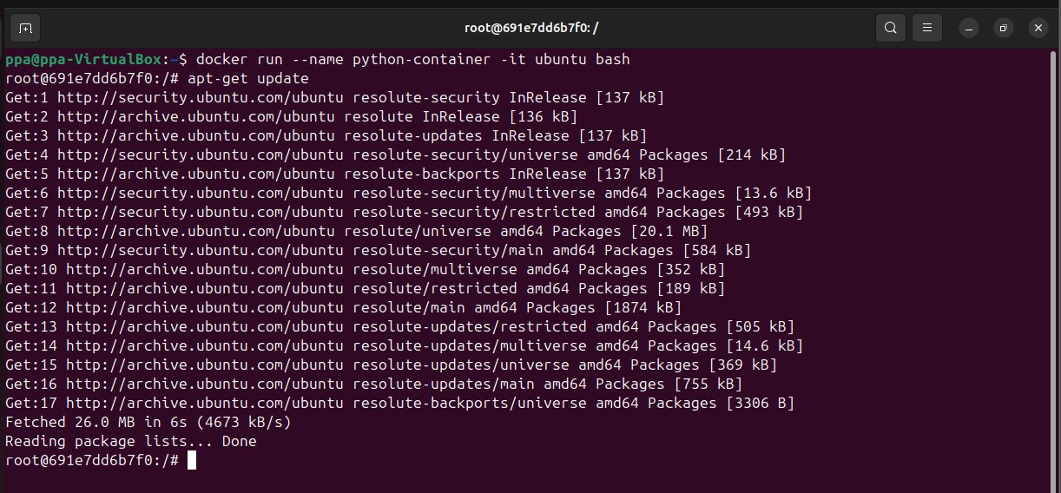
4. Install Python 3 inside the container.
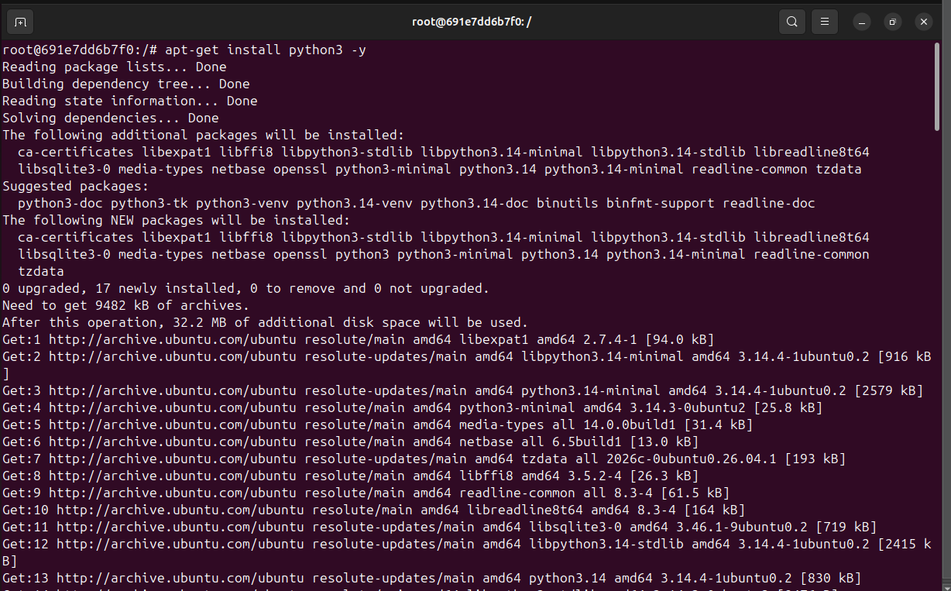
5. Check the installed Python version.
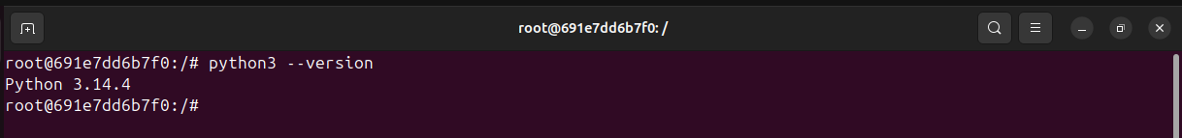
6. Run the following Python statement: print("Hello from my Docker Python container!")
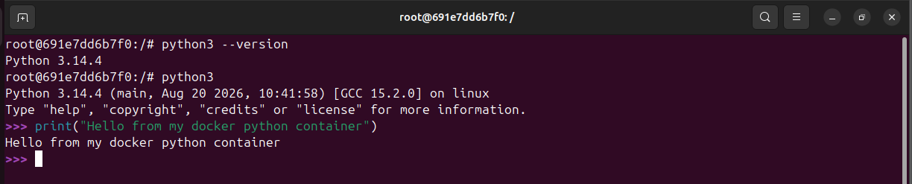
7. Exit from the container.
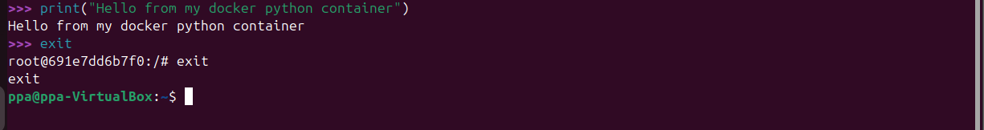
8. Use docker commit to create a custom image named student-python:v1.
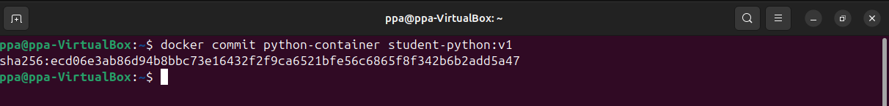
9. Display the list of Docker images and confirm that the custom image was created.
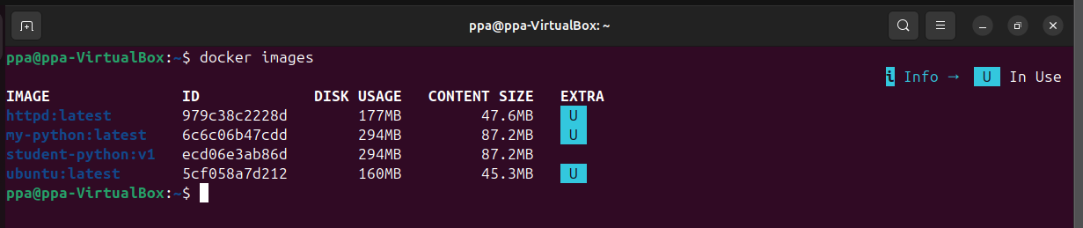
10. Create a new container from student-python:v1 and verify that Python is installed and
Working.
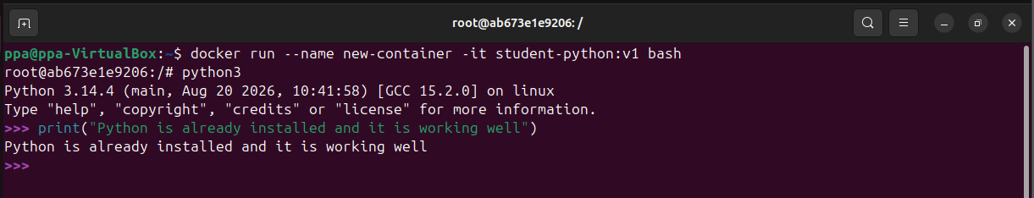

Task 3:
Deploy an Apache web server using Docker by completing the following steps:
1. Pull the latest Apache HTTP Server image from Docker Hub.
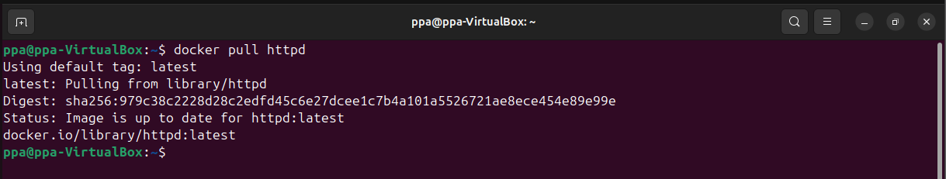

2. Create and run a container named student-apache.
3. Map port 8080 on the host computer to port 80 inside the container.
4. Open http://localhost:8080 in a web browser and confirm that the Apache web server is
running.
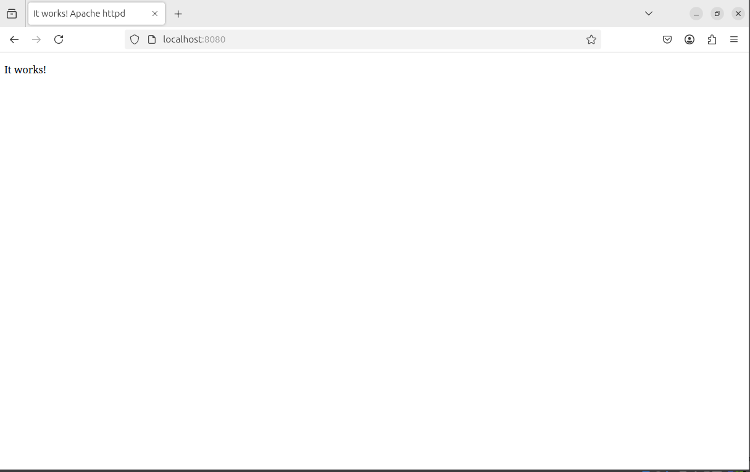

5. Replace the default Apache web page with a customized web page.
The customized web page must include:
• Student name
• Student ID
• Course name
• The heading “My First Docker Website”
• A short paragraph explaining why you are learning Docker
6. Refresh the browser and verify that the customized page is displayed.

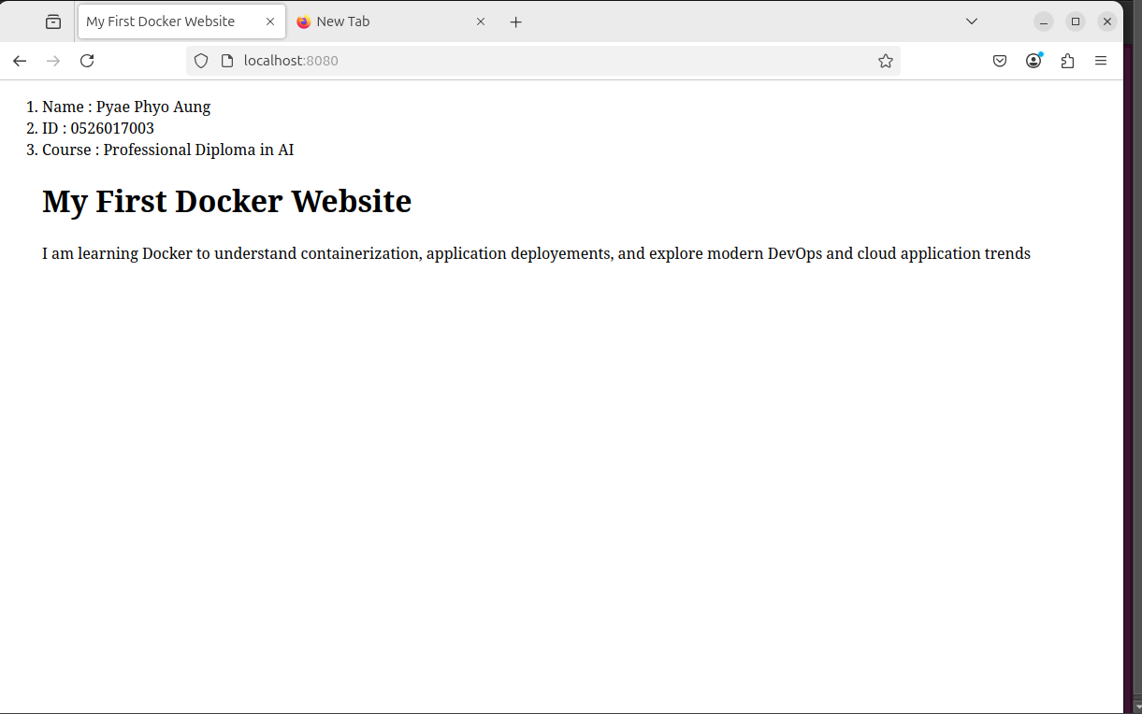

Task 4: Share Web Files Using a Bind Mount
Use a bind mount to share website files between the host computer and an Apache container.
1. Create a folder named docker-website on the host computer.
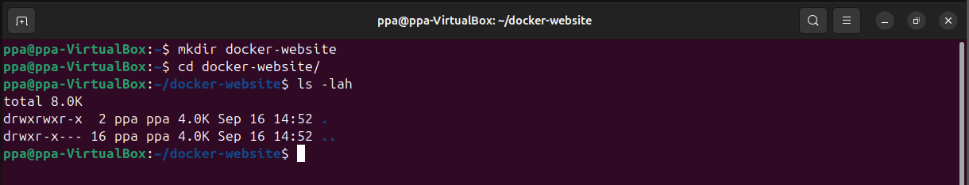

2. Create the following files inside the folder:
docker-website/
├── index.html
└── style.css
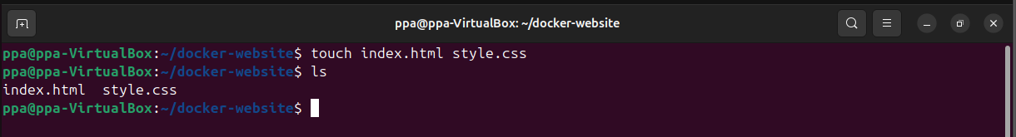

3. Design a simple web page containing your name, student ID, course name and a short
welcome message.
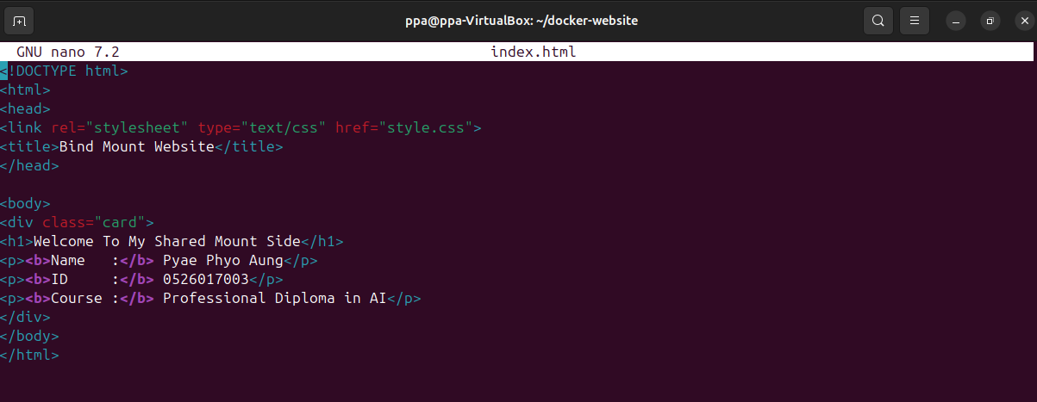

4. Apply basic CSS formatting to the web page.
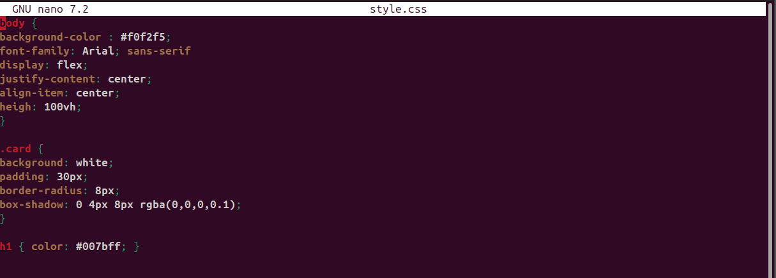

5. Create and run an Apache container named bindmount-web.
6. Use a bind mount to connect the docker-website folder to the Apache web root directory.
7. Map host port 8081 to container port 80.
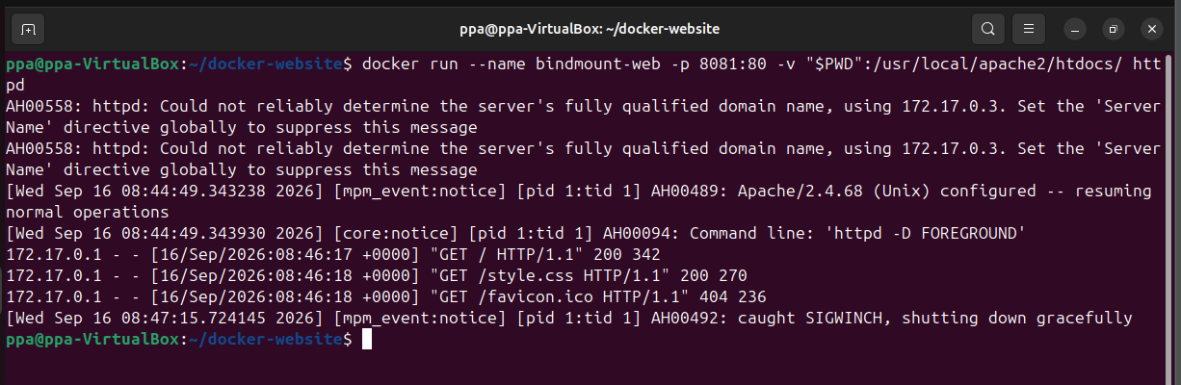

8. Open http://localhost:8081 in a web browser and verify that the website is displayed.
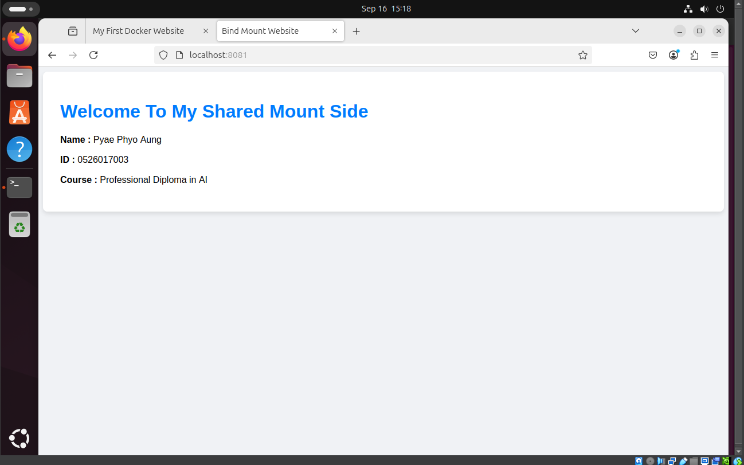

9. Modify the index.html file on the host computer.
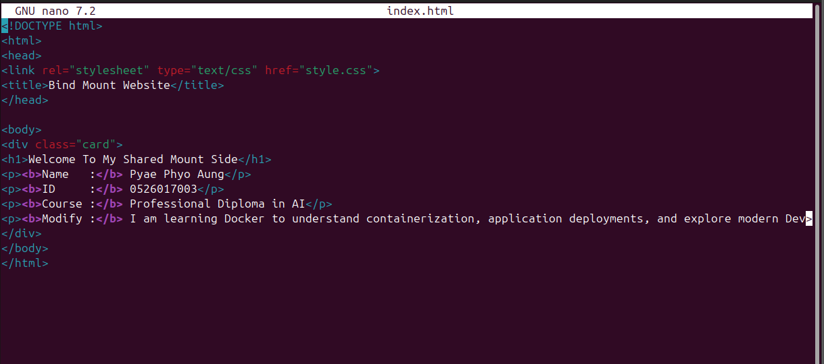

10. Refresh the browser and confirm that the changes appear without rebuilding the image or
restarting the container.

